Setting up Prometheus on Windows OS(locally)

1.First step is to install the Windows Exporter, we will download the file from Github page



2.After the installation we need to check if the exporter is running

We need to open the Services in windows and check if its running



We can access the export from our localhost which is portforwareded to 9182

<http://localhost:9182/>

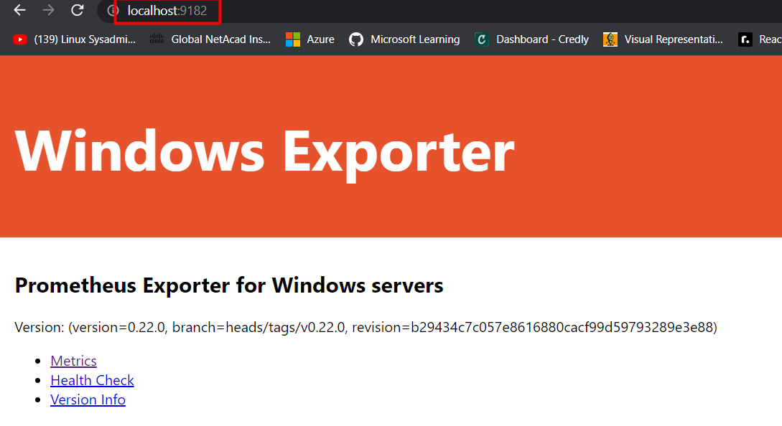

3.Once the exporter is installed and we can access it , we need to run the Prometheus app



But to connect the Exporter and Prometheus monitoring tool we need to configure the Prometheus yaml.file

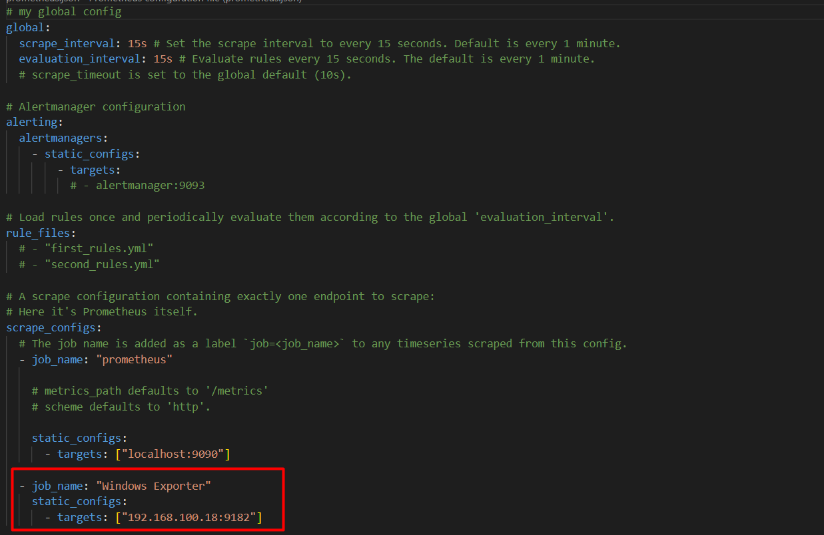

We added a new job which is assigned with the Exporter and our target for this will be our local IP which is 192.168.100.18 and port forwarded to 9182 as we can see in the picture below.

Once this is completed we can access the Prometheus dashboard <http://localhost:9090/>

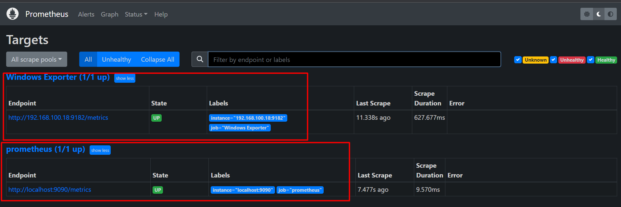

We can see that our targets are up and running .

Also we can the Prometheus Graphical dashboard.

